Create two component like parent Component and Child Component. And Pass Value to parent to child .

Parent Component :

import React, { Component } from 'react'

import FRInput from './FRInput'

 class FRParentInput extends Component {

  constructor(props) {

    super(props)

        //step 1 create ref

        this.inputRef=React.createRef()

  }

  clickHandler=()=> {

this.inputRef.current.focus()

  }

  render() {

    return (

      <div>

        {/\* step 2: Attach the ref to child component using ref \*/}

        <FRInput ref={this.inputRef}></FRInput>

        {/\* Step 4: define click handler \*/}

        <button onClick={this.clickHandler}>Focus Input</button>

      </div>

    )

  }

}

export default FRParentInput

Child Component :

import React from 'react'

// function FRInput() {

//   return (

//     <div>

//     </div>

//   )

// }

//Step 3 : Forward ref from parent to here  child component

const FRInput =React.forwardRef((props,ref)=>{

  return(

    <div>

      <input type="text" ref={ref}></input>

    </div>

  )

})

export default FRInput

Output :

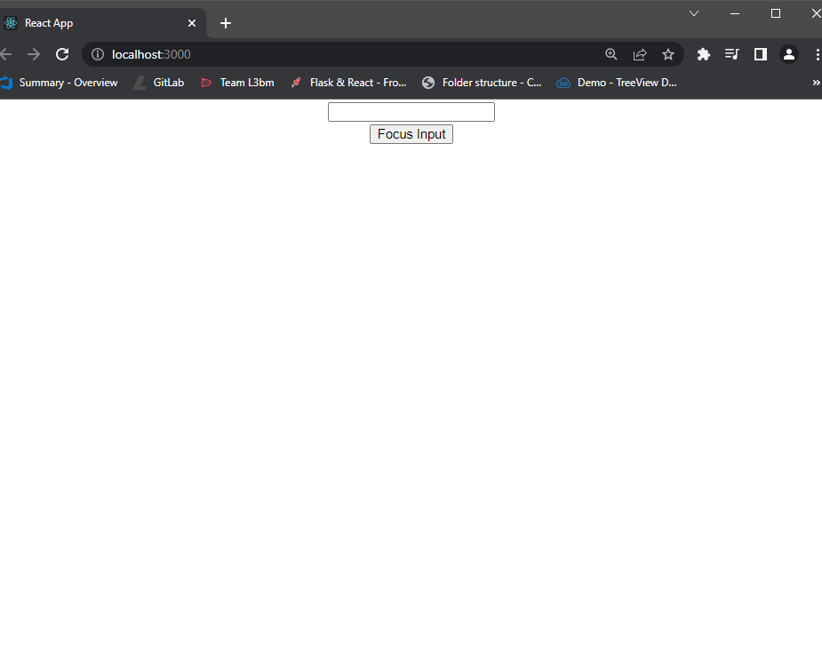

Click button :

